**ASSIGNMENT-8.1**

1. What is the total amount of petrol in volume sold by every distributor?

* Grouping by distributor name
* Calculating the sum of volume sold foe every distribution

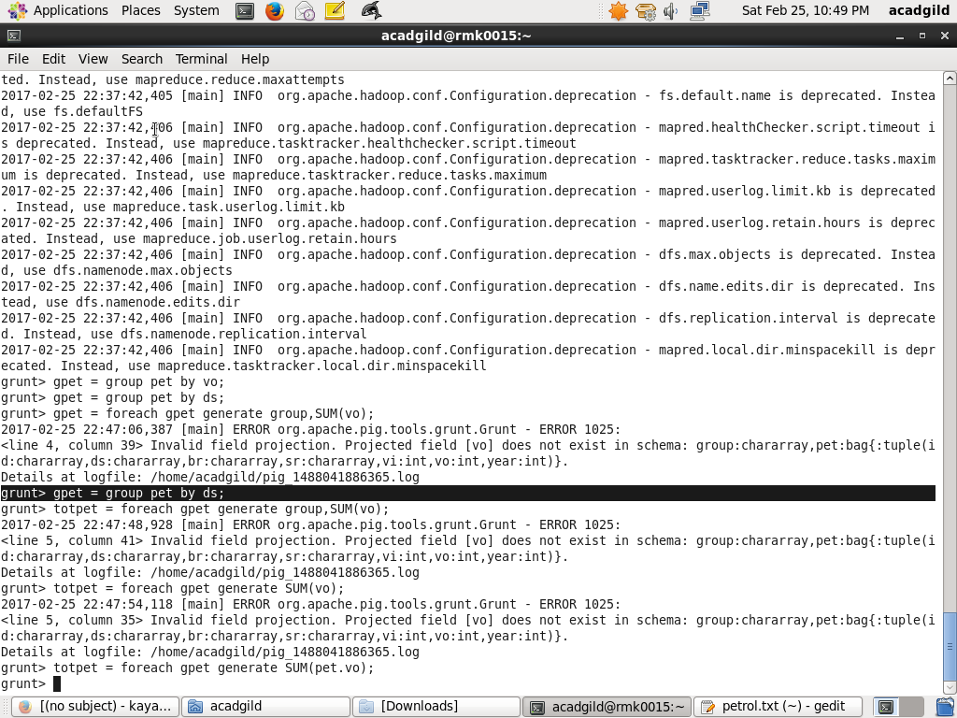

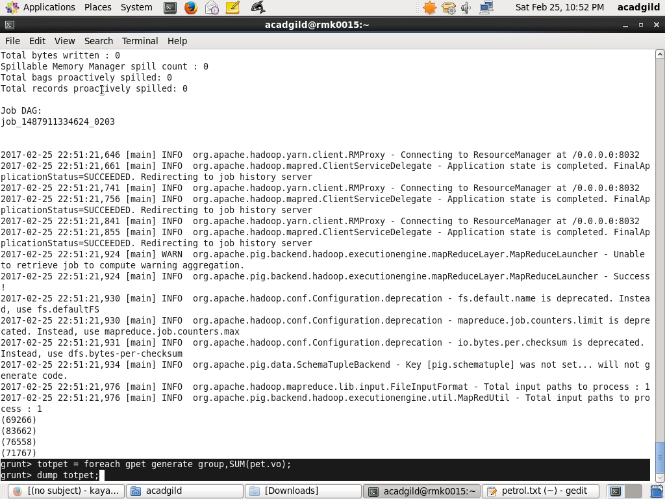

**Output**

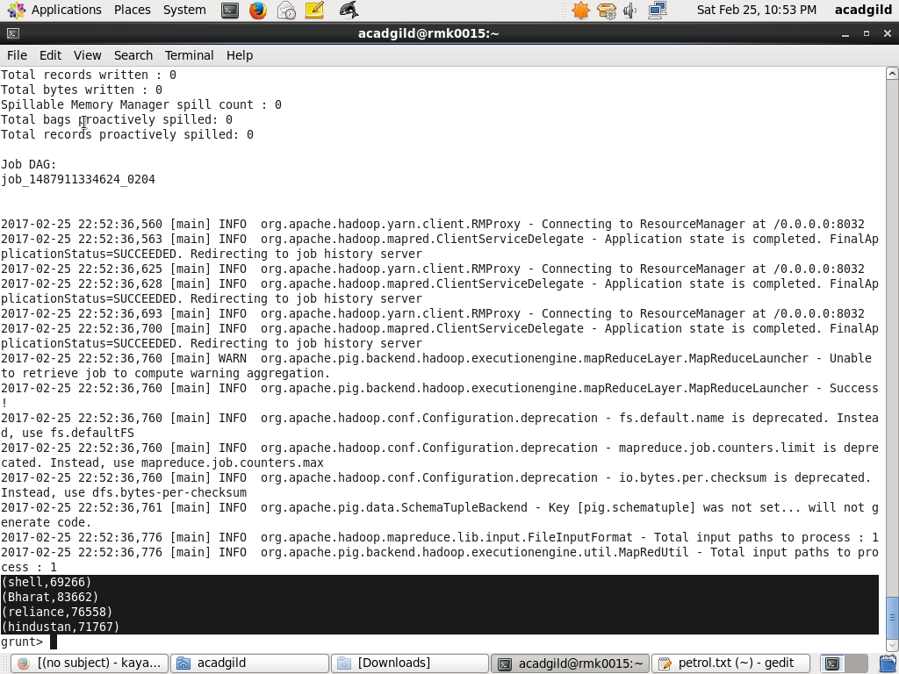

1. Which are the top 10 distributors ID's for selling petrol? Also display the amount of petrol sold in volume.

* Ordering by sell rate

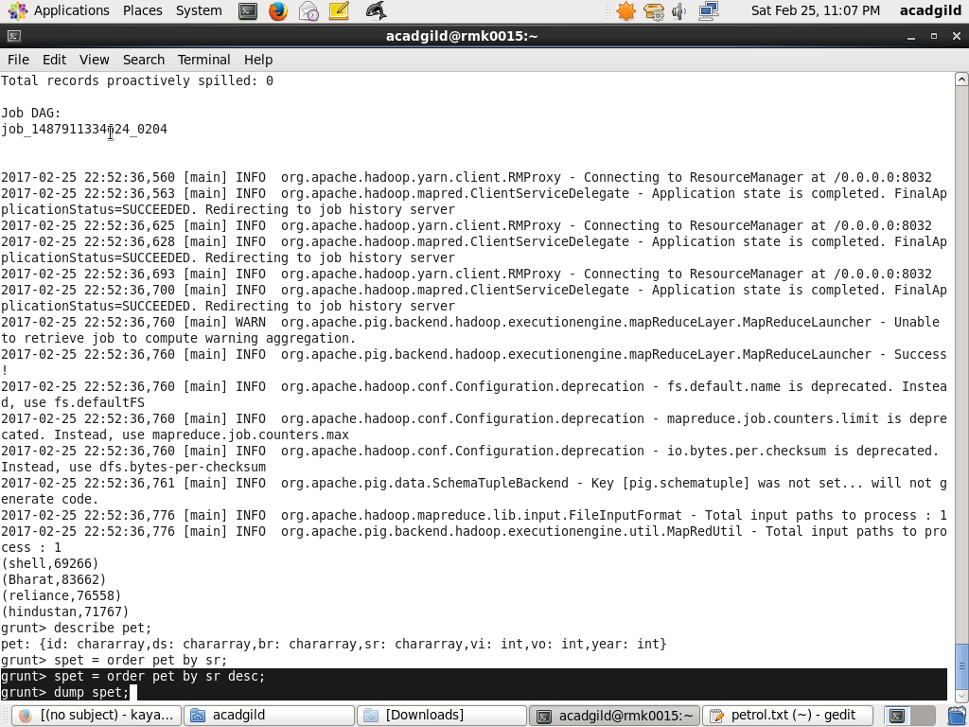

* Limiting top 10

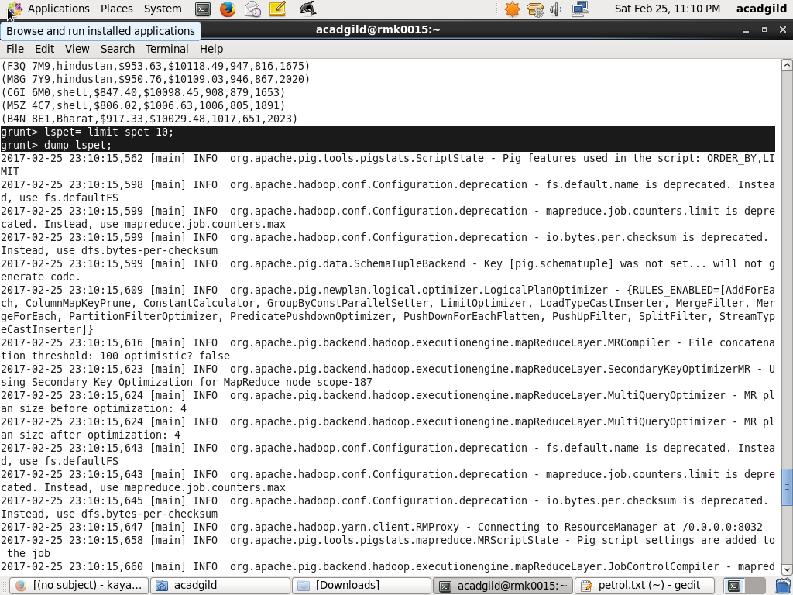

* Generating the needed columns

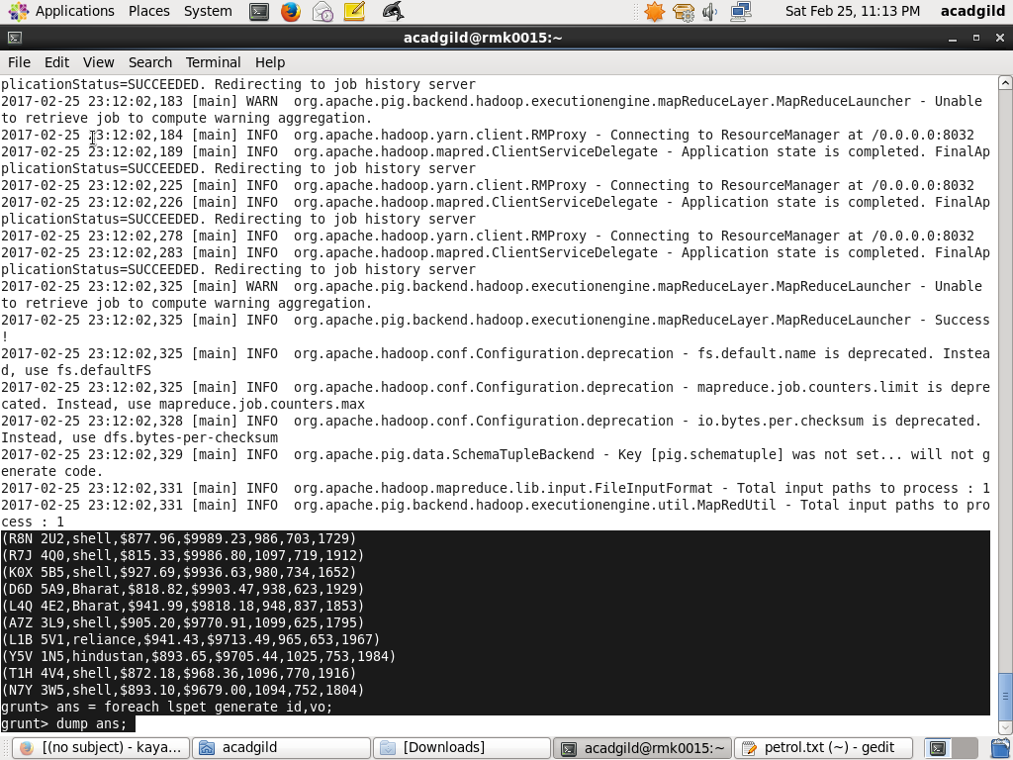

**Output**

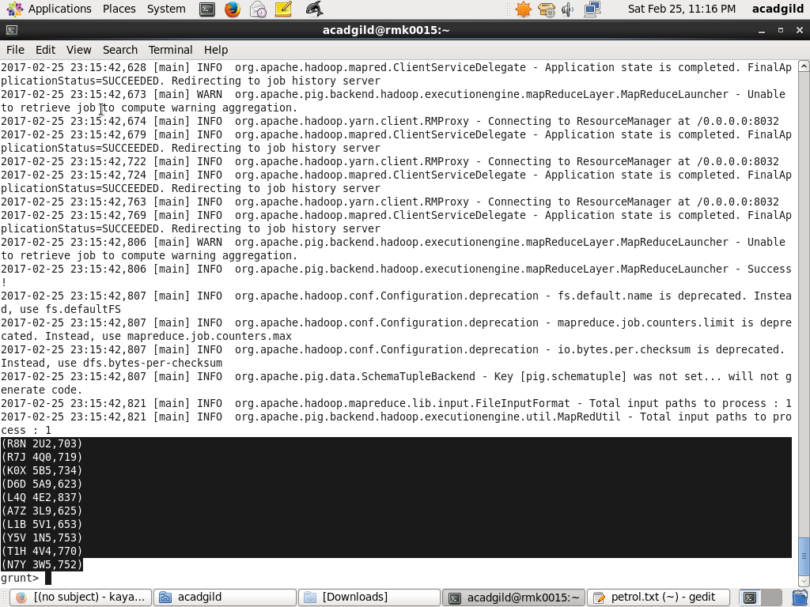

1. List 10 years where consumption of petrol is more with the distributer id who sold it.

* Ordering by volume consumed
* Limit to top 10
* Generating the specific year and id



**Output**

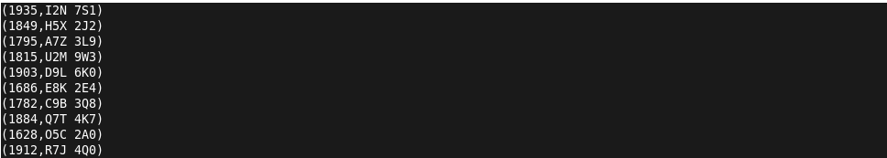

1. Find the distributer name who sold petrol in least amount.

* Ordering by sales rate
* Filtering the top one
* Generating distributor name

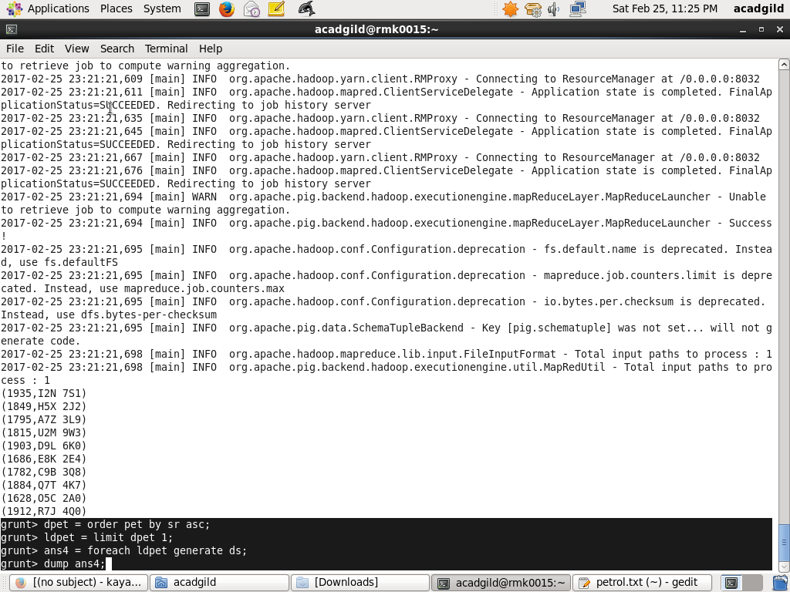

**Output**

